Developing Capacity for Online Sales to Deal with Coronavirus Pandemic
Student’s Name
Instructor’s Name
Date

Developing Capacity for Online Sales to Deal with Coronavirus Pandemic
Research Proposal
Introduction
Coronavirus disease (COVID-19) is a respiratory disease that was declared a pandemic by the world health organization. The disease has affected many countries around the world, with different countries dealing with the disease in different phases. The rate at which the virus spread is very high, and therefore, the government has to put strict measures to help contain the disease such as people to stay indoors. The disease has affected businesses negatively, and because people are not able to move as previously, sales have highly reduced. Companies are running to a loss, with most products that are perishable being destroyed. Consequently, businesses need to use other means to be able to cope with the pandemic. To cope with the challenges, companies need to protect their employees since the organization cannot run without people and also set a cross-functional response team to help enhance the set of processes to maximize the health and safety of customers and facilitating the marketing and sales functions.
Description of the Current Situation
The disease continues to expand globally, and it now has more than one million cases around the world. Industries and small-scale businesses are now devastated because of the rapid decrease in sales, and therefore fear of capsizing due to incurred losses. The reduction in sales is caused by the directives provided to people by the government on how to combat spread of the virus. Similarly, many consumers are now at their homes, and hence they cannot come to purchase products. Coronavirus disease spreads from person to person, and thus when people become into contact with one another, they tend to have contact and may quickly contact the disease hence they are advised to be more than one meter apart (Yan et al., 2020). Through respiratory droplets produced when an infected person sneezes or talks, the droplets can land on another person’s nose, mouth or eyes leading their way into the lungs. The spread of the virus has made it a challenge for people to interact in business, therefore, through given directives by government to stay home and reduce the spread and to contain the virus. The disease has consequently resulted in economic stagnation as the supply chain is not working as it used to previously. Business is also affected because of a shortage of labor and materials, travel restrictions, and logistics challenges through the hub and border closures and tightened controls.
Description of the Projected Plan
The world health organization has always been updating its guidelines on the ways to reduce the spread as well as preventing people while working; therefore, it will be easy to protect employees through training them thoroughly on the guidelines. Every employee is part and family of the business, thus safeguarding them will be one measure to ensure the company runs, and they are protected from the infection. Some of the guidelines to be introduced to the employees are to maintain the physical distance with other employees, ensure cleanliness each time, and avoid non-essential travels. Similarly, there will need to create a cross-sectional response team within the organization. The purpose of the group is to ensure a simple and well-managed set of processes that maximizes the health and safety of employees and customers. Besides, the response team should be led by the Chief Executive Officer of the company and should be divided into several categories, including the supply chain monitoring, employee management and wellbeing, marketing and sales and financial stress testing and contingency planning. Being close to the customers will also help as customers will be able to see that the business is working through combating the diseases as well as they are cared for. Giving customers alternatives, such as ordering products online and in turn be delivered to them by the company (Fernandes, 2020).
Graphics and Graphs
Graph 1: The Chinese industrial production in the first two months of the year
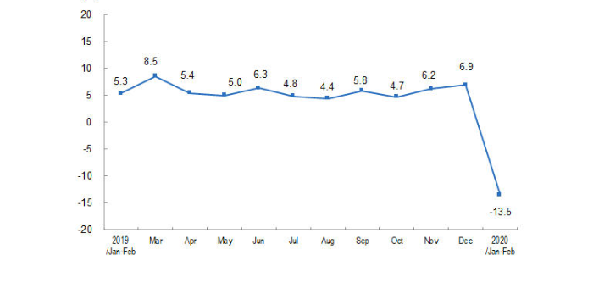
Source: National Bureau of statistics of china
According to National Bureau of Statistics of China (2020), based on the graph, the pandemic resulted in a rapid fall in industrial production in China, the reason being that the Chinese production industry was not prepared for the epidemic. As observed other months from March to December 2019, the production rate was normal; however, in January and February, the production rate had fallen by 13.5%.

Graph 2: The impact of coronavirus on online sales in Italy between February and March 2020

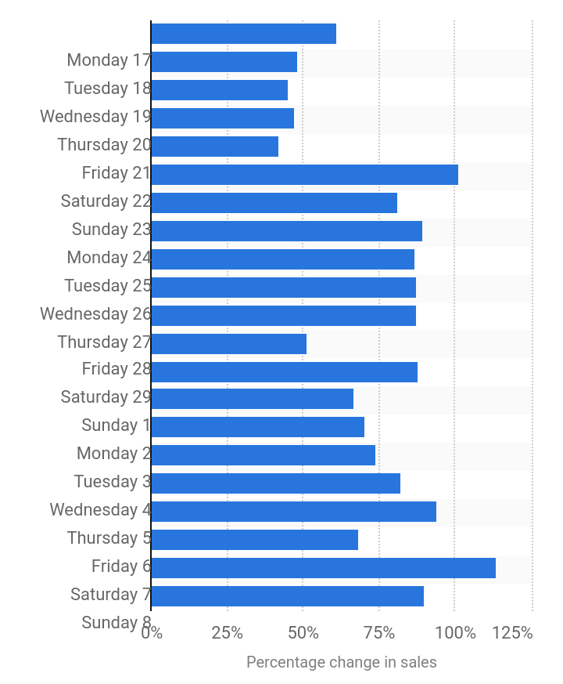

Source: statista.com
The graph indicates that products purchased online increased progressively during March. According to Statista.com (2020), the graph, therefore, provides proof that for companies to increase their sales, they can use online sales.
Qualifications
People to be involved in the implementation of the solutions are chief Executive Officers in companies and other senior officials in organizations, as they are leaders of the businesses and organizations. They are the ones who control the organizations and guide what should be done in case of arising situations and take responsibility for the actions they take. Other parties involved include employees, customers, government representatives and medical experts. Employees and customers are required to comply with the guidelines given while government representatives are to provide support to the organization to ensure the supply chain continues to move on well while the medical experts are to provide solutions to other factors within organizations which may lead to contracting the infections.
Summary
The benefits of taking the measures are to protect employee’s life from the disease and ensure employment rate is maintained in the country. The plan taken will also maintain the supply chain in the country from production and transportation of goods as well as make it available to consumers through purchasing online. However, those who come physically to the company are provided with enough prevention to secure their lives. Moreover, the economy of the country will also be sustained.
The costs of implementing the projects to the business are the need to employ more employees to achieve sufficient suppliers to customers who have ordered their products online. Moreover, employee training and education will also affect the business by ensuring they understand what is needed and how to keep themselves safe.
Budget
The budget proposed to maintain a business making sales online and protecting an average of one hundred employees is stated below.
Online system $10,000
Travel cost $2000
Medical expert $1000
Employee safety gears $3,500
Other costs $200
Total $16,700

References
Yan, B., Stuart, L., Tu, A., & Zhang, T. (2020). Analysis of the Effect of COVID-19 on the Stock Market and Potential Investing Strategies. Available at SSRN 3563380.
Fernandes, N. (2020). Economic effects of coronavirus outbreak (COVID-19) on the world economy. Available at SSRN 3557504.
National Bureau of Statistics of China. (2020). Industrial production Operation in the First Two Months of 2020. Retrieved from http://www.stats.gov.cn/english/PressRelease/202003/t20200317_1732640.html
Statista.com. (2020). Impact of coronavirus (COVID-19) on online sales in Italy between February and March 2020. Retrieved from www.statista.com/statistics/1101844/impact-of-corona-virus-covid-19-on-e-commerce-in-italy/

